**User’s manual**

# Rules of the game

**The manual was written for rectangular grid because the hexagonal grid is not available in our game.**

**The range rule is orange.**

1. 2 players play on a 8x7 rectangular grid.
2. There are 2 tokens : North, located on the middle top of the grid and South, located on the middle bottom of the grid.
3. At each turn, the player moves and he has to kill a cell. With range rule, he can’t kill a cell over 3 cells. After that, the player can no longer move on it.
4. The winner is the player who blocks the other player.
5. The player lose when all direction are occupied by a dead cell.

# To start a game

Start Linux operating system and download files “board.o” and “board.h” on the <https://ecampus.unicaen.fr> website. Create a folder and name it “game”, move files in the folder, then open a terminal. Write next script:

$ gcc –Wall main.c board.o –o game

Then:

$ ./game

The game start in the terminal and you could play the game.

# Play the game step by step

**Step 1:** **Launch** the game

**Step 2 :** Choose if you want to play with a ranged rule. Write 1 to select a ranged game or 2 to select normal game.

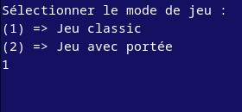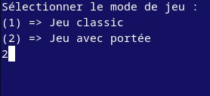

**Step 3 :** Enter the name of north player

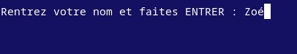

**Step 4 :** Enter the name of south player

**Step 5:** North player **choose the direction** that he would go. When the direction are represented by a cross ‘X’ this means that directions are not available. It exists eight direction represent by a number: 1 for North-west, 2 for North, 3 for North-east, 4 for West, 6 for East, 7 for South-west, 8 for South, 9 for South-east.

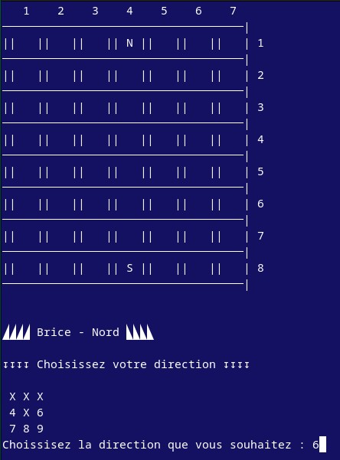

**Step 6 :** You has to **choose the cell you want to kil**l (block). In order to chose the cell, the player must write a number of line and a number of column of cells.

**Step 7 :** The other player choose the direction that he would go and enter coordinate of cell he want to kill it.

# End of the game

When one player blocks his adversary, the game stops by itself.

To abort a game in a middle of a game part, press simultaneously the keyboard keys “ctrl” and ”c”.

